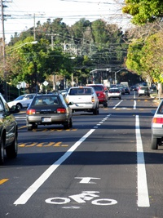
Buchanan Bicycle and Pedestrian Plan.
The City of Albany started a process to develop 35% Plans, Specifications and Engineering (PS&E), as well as environmental work and traffic analysis for the Buchanan St Bicycle path project. The proposed path was first envisioned in the Albany Bicycle Master Plan as a way to close the east-west gap between the Ohlone Greenway and the Bay Trail. Later, the City engaged in a feasibility analysis of the Buchanan St path concept. Several options were prepared as a result of this analysis and the preferred alternative would align the path along the south side of Marin Ave, continuing along the south side of Buchanan St and providing a crossing to the north side of Buchanan St either at Taylor or Pierce Streets.
In March 2007, the City obtained a grant from the Alameda County Transportation Improvement Program (ACTIA) for the development of 35% PS&E, environmental work and traffic analysis for this project. Matching funds for this grant are provided by Albany residents through Measure F. The consultant selection process took place in December 2007 and DMJM Harris, formerly Korve Engineering was selected to work on the project. The City Council awarded contract at its February 19, 2008 meeting and work began in March with a kick off meeting involving City staff and the projects’ stakeholders. The consultant is currently working on design alternatives that would be presented to the Traffic and Safety Commission and the public in the fall 2008. Final plans and environmental documents are expected to be finalized in May 2009, according to the project schedule. The City plans to seek additional funding for the construction phase of this project.
For further information, contact:
Aleida Andrino-Chavez, Transportation Planner
(510) 528-5759
achavez@albanyca.org

