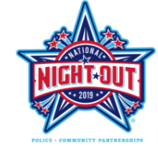

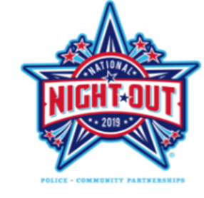

**Neighborhood Satisfaction Survey**

*Please help us understand your neighborhood better. Thank you!*

1. I feel my neighborhood is safe.

1 2 3 4 5 6 7 8 9 10

not safe very safe

1. I know my neighbors.

1 2 3 4 5 6 7 8 9 10

not safe very safe

1. The biggest issue in my neighborhood is:

* parking/speeding
* blight house(s)
* disorderly conduct
* trash/littering
* crime
* other _____________

1. My block has had a community gathering in the last year.

* National Night Out
* Block Movie Night
* Block party
* Neighborhood Watch meeting
* other ______________

1. If I could change ONE thing about my neighborhood it would be:
2. **Neighborhood Satisfaction Survey**

*Please help us understand your neighborhood better. Thank you!*

1. I feel my neighborhood is safe.

1 2 3 4 5 6 7 8 9 10

not safe very safe

1. I know my neighbors.

1 2 3 4 5 6 7 8 9 10

not safe very safe

1. The biggest issue in my neighborhood is:

* parking/speeding
* blight house(s)
* disorderly conduct
* trash/littering
* crime
* other _____________

1. My block has had a community gathering in the last year.

* National Night Out
* Block Movie Night
* Block party
* Neighborhood Watch meeting
* other ______________

1. If I could change ONE thing about my neighborhood it would be: