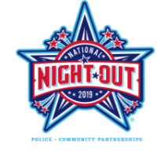
Neighborhood Block Party!

Get to know your neighbors!
Celebrate National Night Out!

Tuesday, August 6th, 2019

National Night Out is a nationwide annual event
designed to raise crime prevention awareness,
strengthen neighborhood spirit and unity, and
foster community-police partnerships.

Come join your neighbors!

Location: _____________________________
Time: _____________________________
Please bring: _____________________________
Contact: ______________ Phone: ________
Neighborhood Block Party!

Get to know your neighbors!
Celebrate National Night Out!

Tuesday, August 6th, 2019

National Night Out is a nationwide annual event
designed to raise crime prevention awareness,
strengthen neighborhood spirit and unity, and
foster community-police partnerships.

Come join your neighbors!

Location: _____________________________
Time: _____________________________
Please bring: _____________________________
Contact: ______________ Phone: ________

